Migration from QC to Jama

Part 1 Excel Report Export

# Precondition

## 1.1 Install TDConnect.exe

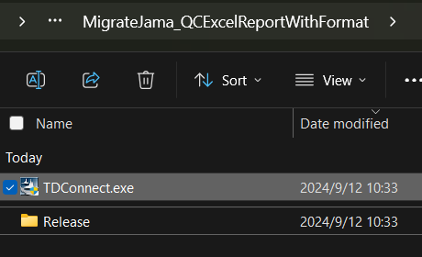

## 1.2 Launch MigrateJama_QCExcelReport.exe

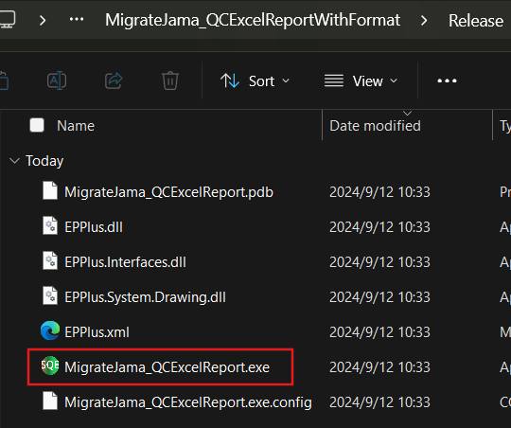

# Connection for QC

QC Connection, select Project, input User Name, Password and click “Test QC Connection” for login the correct project.

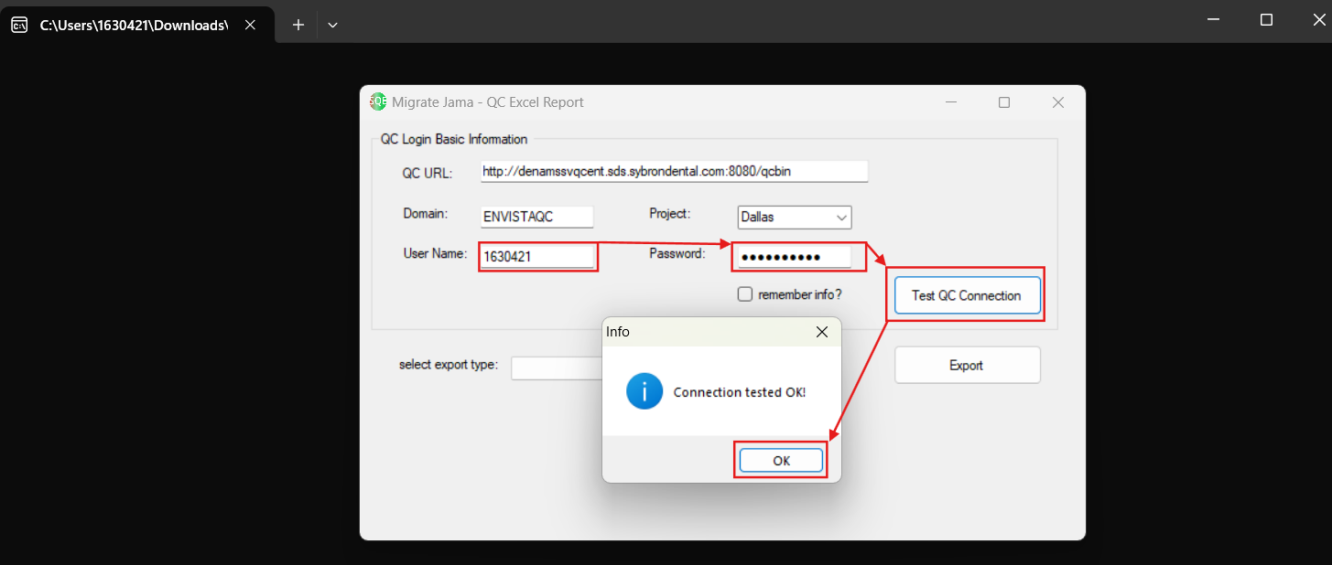

# Export Excel Report

### 3.1 Export Excel Report of QC Requirement, Test Plan, Trace of Requirement to Test Case

* 1. Select an item in list of “Select export type”.

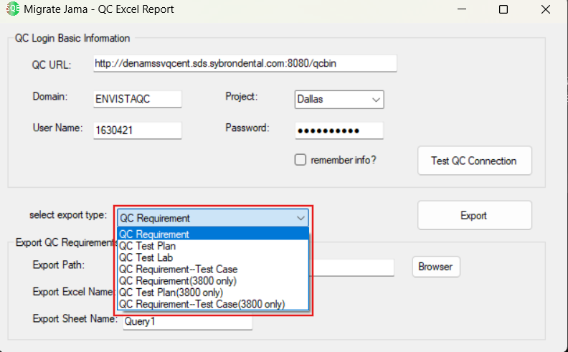

Notes: Items “QC Requirement(3800 only)”, “QC Test Plan(3800 only)”, “QC Requirement--Test Case(3800 only)” only for export of Project:Prague’s 3800 reports, these items don’t suit for other projects.

* 1. Click button “Browser”, select a path for set “Export Path” or input path for it. Other textbox you can leave it as default settings, like “Export Excel Name” and “Export Sheet Name”

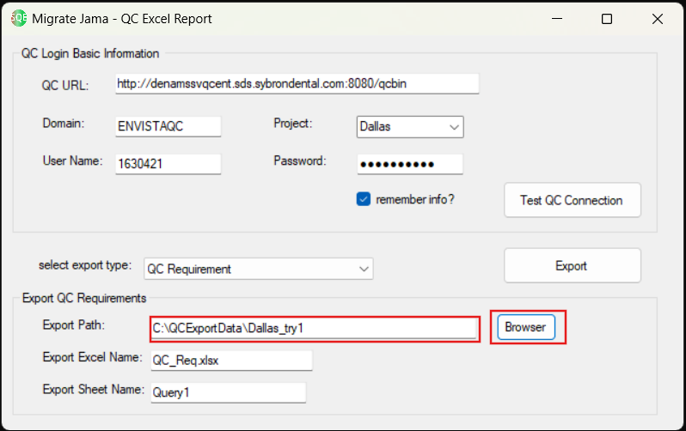

### 3.2 Export Excel Report of QC Test Lab

1. Select “QC Test Lab” in list of “Select export type”.

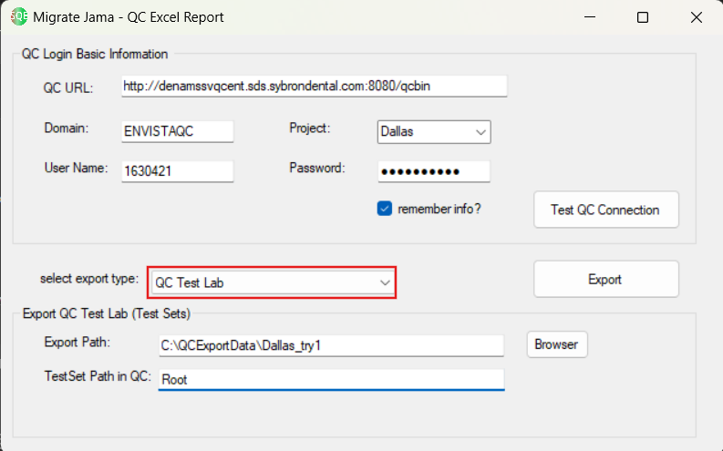

1. Click button “Browser”, select a path for set “Export Path” or input path for it.
2. Input “Test Set Path in QC”, you can using * at end for fuzzy matching, using ; for split path.

I.e., The goal is to export excel reports of Test set in folders

“CS 3600 Access Upgrade Tool”,

”2019-01-15_3.2.0.6 & 3.2.0.7 (Internal TT)”,

”2019-01-29_3.2.0.8 (Internal TT)”,

”2019-02-18_1.0.0.200 (Internal TT)”,

“2019-02-26_1.0.0.300 (Internal TT)”,

The value of “Test Set Path in QC” should be “Root\CS 3600 Access Upgrade Tool\V 1.0.0.1_CS 3600 Access Upgrade Tool;Root\Dallas\2019-01*;Root\Dallas\2019-02*;”

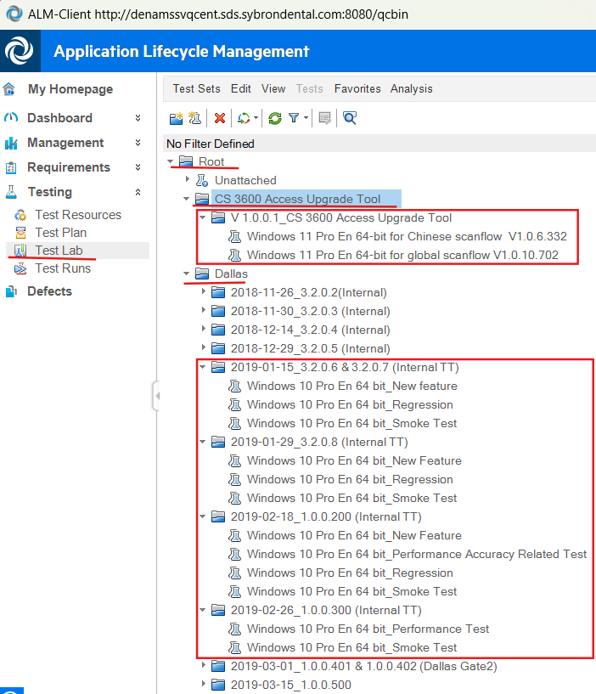

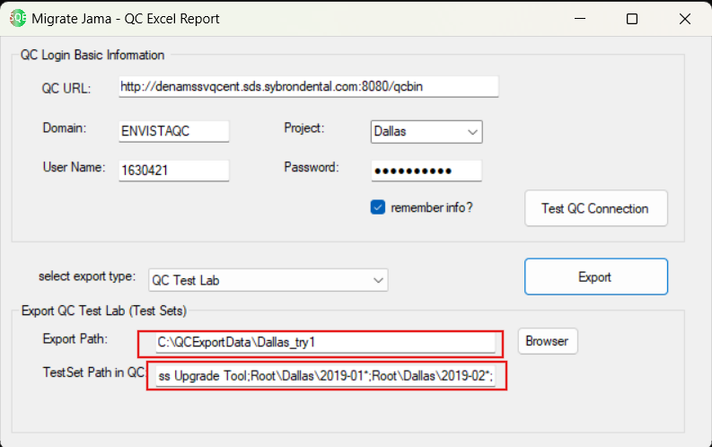

1. The export result is one export is one folder with same named excel report which contains all test sets.

